Missionaries and Cannibals Problem

Aim

To write and execute a Python program to solve the Missionaries and Cannibals problem using the Breadth-First Search (BFS) algorithm.

Algorithm
- Represent the state as (Missionaries, Cannibals, Boat Position).
- Start from the initial state (3,3,Left).
- Generate all valid boat movements.
- Check whether missionaries are safe on both river banks.
- Store unexplored valid states in a queue.
- Continue until the goal state (0,0,Right) is reached.
- Display the solution path.

Procedure
- Open a Python IDE.
- Type the program.
- Save it with a .py extension.
- Run the program.
- Observe the sequence of valid crossings.
Code:
from collections import deque
def is_valid(m_left, c_left):
m_right = 3 - m_left
c_right = 3 - c_left
if (m_left > 0 and c_left > m_left):
return False
if (m_right > 0 and c_right > m_right):
return False
return True
def solve():
start = (3, 3, 1) # (Missionaries, Cannibals, Boat Left)
goal = (0, 0, 0)

queue = deque([(start, [])])
visited = set()
moves = [(1,0), (2,0), (0,1), (0,2), (1,1)]
while queue:
(m, c, boat), path = queue.popleft()
if (m, c, boat) == goal:
return path + [(m, c, boat)]
if (m, c, boat) in visited:
continue
visited.add((m, c, boat))
for dm, dc in moves:
if boat == 1:
nm, nc, nb = m - dm, c - dc, 0
else:
nm, nc, nb = m + dm, c + dc, 1
if 0 <= nm <= 3 and 0 <= nc <= 3:
if is_valid(nm, nc):
queue.append(((nm, nc, nb), path + [(m, c, boat)]))
solution = solve()

print("Solution Path:")
for step in solution:
print(step)

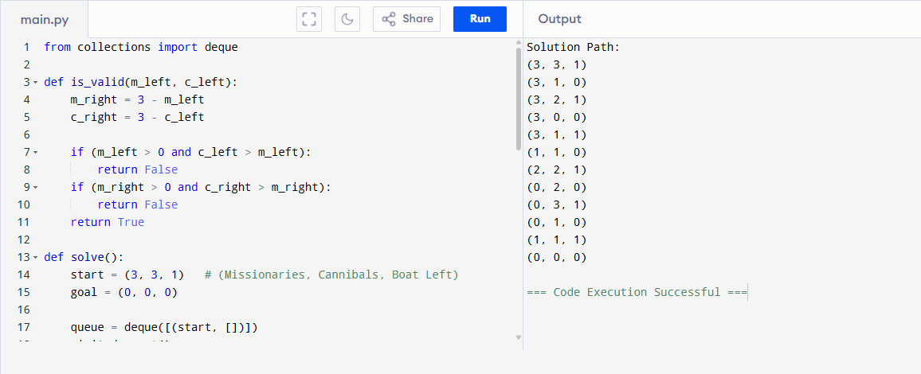
Result
The Python program was executed successfully and the Missionaries and Cannibals problem was solved using the BFS algorithm.

Vacuum Cleaner Problem

Aim
To write and execute a Python program to simulate the Vacuum Cleaner problem using a simple reflex agent.

Algorithm
- Start with the initial room conditions.
- Check the current room.
- If the room is dirty, clean it.
- Move to the other room.
- Repeat until both rooms are clean.
- Display the final state.

Procedure
- Open a Python IDE.
- Enter the Vacuum Cleaner program.
- Save it with a .py extension.
- Execute the program.
- Observe how the vacuum cleaner cleans both rooms.

Code:

def vacuum_cleaner(roomA, roomB, location):

print("Initial State")

print("Room A:", roomA)

print("Room B:", roomB)

print("Vacuum at:", location)

while roomA == "Dirty" or roomB == "Dirty":

if location == "A":

if roomA == "Dirty":

print("Cleaning Room A")

roomA = "Clean"

location = "B"

else:

if roomB == "Dirty":

print("Cleaning Room B")

roomB = "Clean"

location = "A"

print("\nFinal State")

print("Room A:", roomA)

print("Room B:", roomB)

vacuum_cleaner("Dirty", "Dirty", "A")

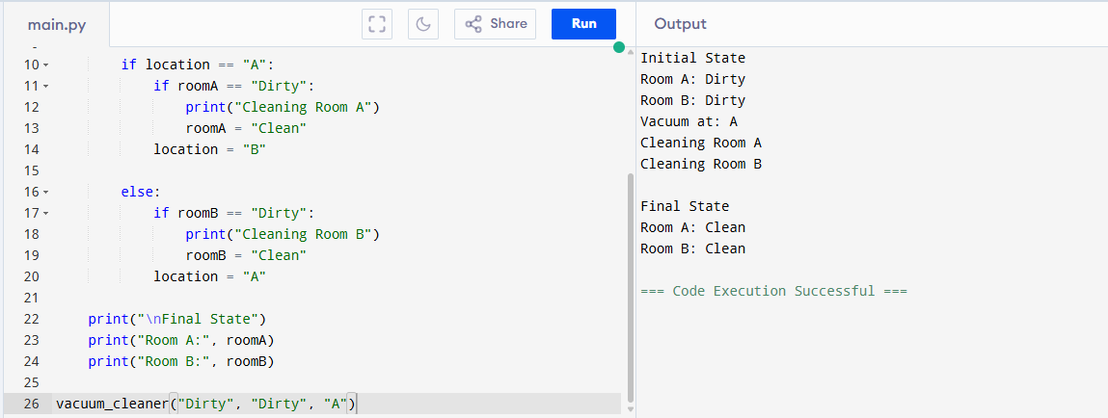

Result
The Python program was executed successfully, and the vacuum cleaner cleaned all dirty rooms using a simple reflex agent strategy.

